Title

James L. Maino*1 & Author Name2,3

1 **cesar**, 293 Royal Parade, Parkville, Victoria 3010, Australia

2 School of BioSciences, The University of Melbourne, Victoria 3010, Australia

3Other affiliation

*corresponding author. mail: [jamesmaino@gmail.com](mailto:jamesmaino@gmail.com), ph: +61400150564, orcid: 0000-0002-9907-0062

Keywords:

# Abstract

Abstract here.

# Key message

* Message 1
* Message 2
* Message 3

# Author Contribution Statement

All authors conceived and designed the research. JM reviewed the literature, compiled the data, and conducted the analysis. JM developed the simulation model. All authors wrote, read, revised and approved the manuscript.

# Introduction

Set context.

Define problem or opportunity– e.g. knowledge gap.

Relate to similar problems and solutions

Justify approach.

Summarise approach

Define research questions

# Methods

Methods here.

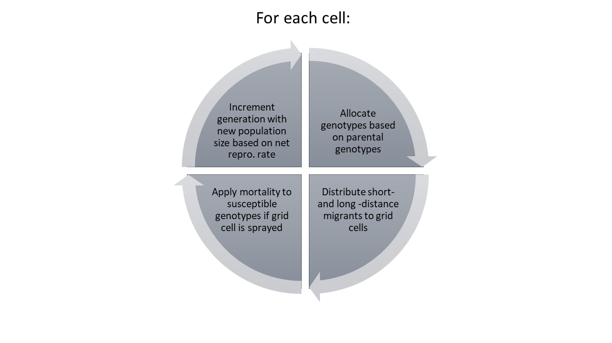

**Figure 1.** Figure legend

**Table 1. Table title**

|  |  |  |  |
| --- | --- | --- | --- |
| **Parameter** | **Value** | **Description** | **Justification** |
| *Parameters fixed in sensitivity analysis* | | | |
| C | 10 | Linear dimension in metres of each grid cell. | See Figure 2 |
| mr | 0.10 | Migration rate, probability of leaving cell (into adjacent cell) each local migration step. | See Figure 2 |

# Results

Results here.

# Discussion

Discussion here.

# Acknowledgements

The authors acknowledge Not Author for discussion during the conception of this study, and Not Author for assistance with figure design. This work was supported by funding from the Funder.

# Compliance with Ethical Standards

**Funding**: This study was supported by funding from the Funder (UM00049, UM00057).

**Conflict of Interest**: The authors declare that they have no conflict of interest.

# References